FTF FY 2023 Performance Scorecard USAID Bangladesh

This Feed the Future (FTF) Performance Scorecard assesses the USAID Bangladesh progress toward FY 2030 Performance Targets.

# Performance Overview



The FY 2023 **On track** value is determined by drawing a line from the baseline (FY 2022) to the FY 2030 Target. For FY 2023, Performance Targets are considered **On track** if they have reported at least 90% of that value.

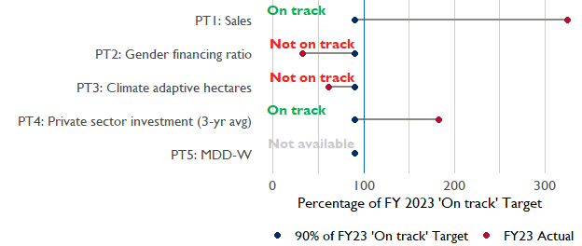

**Note:** *For Performance Target 2 (Gender financing ratio), the target is to increase financing to females for those OUs that are already achieving parity ($1).*

*For Performance Target 4 (PSI), all targets are relative to the last three years’ reporting. In future years, the interim targets may increase.*

*For Performance Target 5 (MDD-W), all FY23 actual values are also the baseline, and may have been collected in a prior year. See the detail page for more information.*

*See detailed* [*methodology document*](https://docs.google.com/document/d/13n-43ppFiGKauscQ7HaAiQDCM4DssGEgRdq2fMyTDn0/edit) *here. If you have questions, please email the FTF Data and Analytics team at* [refs.adl.da@usaid.gov](mailto:refs.adl.da@usaid.gov).

### Performance Target (PT) Details

This section shows PT scores for each applicable PT for USAID Bangladesh.

## Performance Target 1: Value of annual sales of producers and firms receiving USG assistance



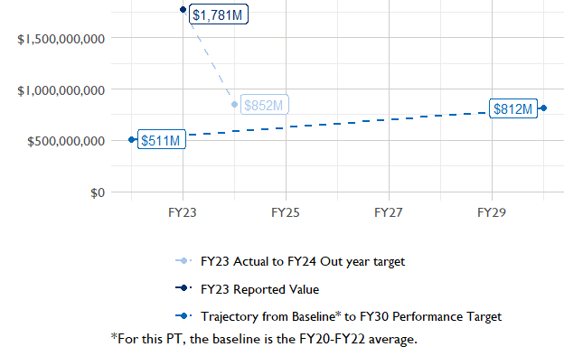

In FY 2023, USAID Bangladesh had 9 activities that aligned the ‘Value of annual sales from producers and firms receiving USG assistance’ (EG.3.2-26), and 7 contributed to the sales total of $1,780,800,000.

###### Performance Target 2: Value of financing accessed by female FTF participants per $1 of financing accessed by male FTF participants



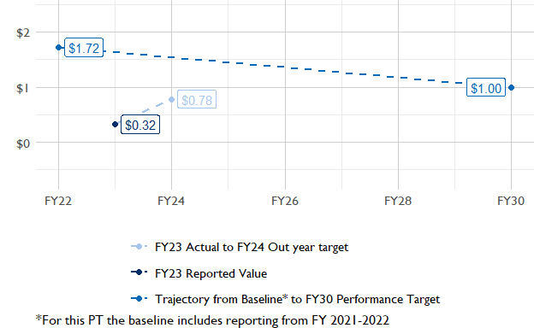

In FY 2023, USAID Bangladesh had 3 IMs/Activities that reported all four sex disaggregates needed to contribute to PT2. The total value of financing among all activities, regardless of disaggregates, was $11,190,000 (EG.3.2-27 total), with $11,190,000 that was disaggregated by females and males, and an additional $0 to ‘mixed’ firms that have both males and females, and NA that was not sex disaggregated.

###### Performance Target 3: Number of cultivated hectares under climate adaptation/climate risk management practices and technologies with USG assistance



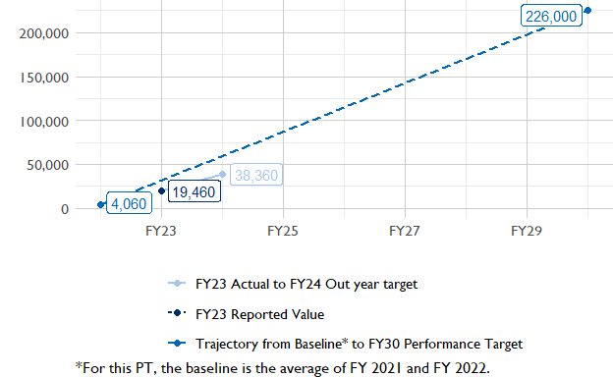

In FY 2023, Bangladesh had 19 activities that aligned the indicator for hectares under improved management practices (EG.3.2-25). Of those activities, 3 reported on the ‘Climate adaptation/climate risk management’ disaggregate and contributed to the OU total for this PT.

###### Performance Target 4: Value of private sector investment leveraged by the USG to support food security and nutrition



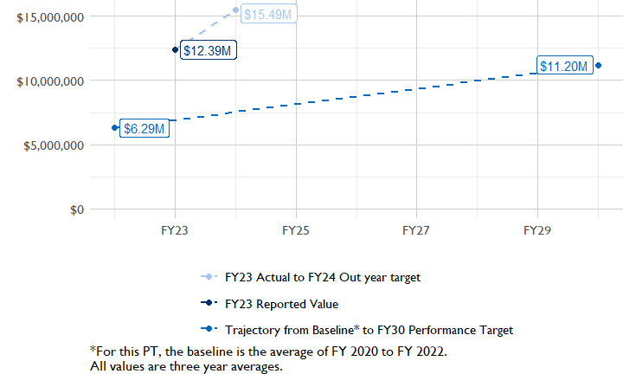

In FY 2023, Bangladesh had 7 activities that aligned the private sector investment indicator (EG.3.1-15/-14), ‘Value of new private sector investment leveraged by the USG to support food security and nutrition [IM-level]’, and 7 contributed to the OU total in FY 2023.

###### Performance Target 5: Percent of women consuming a diet of minimum diversity (MDD-W)



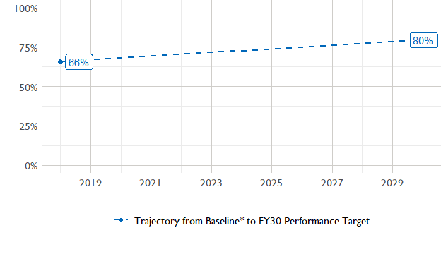

The baseline population-based survey (PBS) for USAID Bangladesh was in 2018 and showed that 66% of women in the ZOI had consumed a minimally-diverse diet in the previous day or night. The FY30 target is 80% percent.The most recent PBS was in 2022, but results are not yet available. The following PBS is scheduled for .

### National Context

National level data was collected from the [World Bank’s Open Data portal](https://data.worldbank.org/) that measures key indicators at the national level.

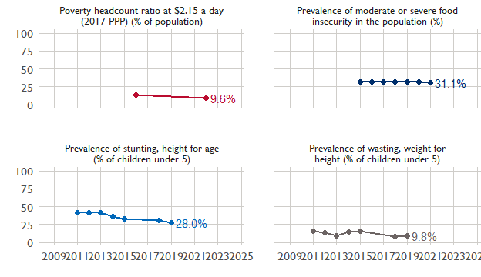

## Agricultural Transformation Index Score

The IFPRI Agricultural Transformation Index (ATI) Score is a high level indicator of the status of agricultural market systems in each country.

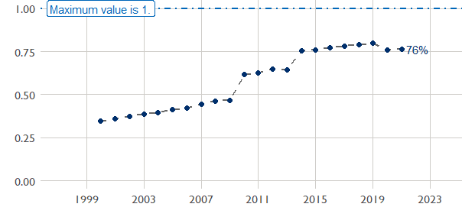

## Budget Trend

At the Operating Unit level, the Performance Targets are based in part on the FY 2024 budget request. The budget chart below includes EG.3 money only.

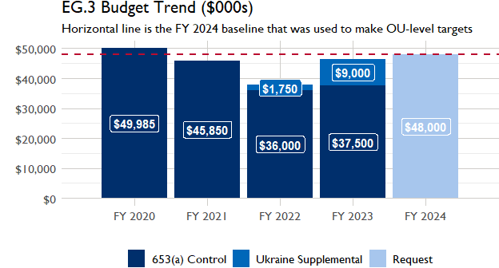

## Active Portfolio

The following activities are considered “active” based on their reporting in FY 2023 and expected FY 2024 reporting. The Analytics, Data and Learning Division defines an “active” activity as one that reported targets, actuals, or deviation narratives for the current year (FY 2023), or the next out year targets (i.e. FY 2024).

## Top Activities (Award Disbursements and Results)

This section highlights the 5 activities (out of the total 19 in the USAID Bangladesh (BANGLADESH) portfolio) that have the highest level of FY 2023 annual disbursements and highest reported values for the relevant indicators. The first table below shows activities with the highest total transaction amounts. The columns to the right indicate if these activities are reporting on relevant PT indicators.

| Award Number | Activity Code | Activity Name | FY23 Disbursements | PT1 | PT2 | PT3 | PT4 |
| --- | --- | --- | --- | --- | --- | --- | --- |
| 72038818CA00005 | 1616 | FTF Bangladesh Nutrition Activity | $5,334,303 | - | - | - | X |
| 72038818IO00002 | 1612 | FTF Bangladesh Aquaculture Activity | $3,792,335 | X | X | - | X |
| 72038821CA00005 | 4553 | Feed the Future Bangladesh Livestock and Nutrition Activity | $3,723,131 | X | X | - | X |

The next table (below) shows the activities that reported the highest values for the relevant PT indicators. The total disbursements are included, if available.

| Award Number | Activity Code | Activity Name | Total Disbursements | Sales | Hectares | PSI |
| --- | --- | --- | --- | --- | --- | --- |
| 72038821CA00005 | 4553 | Feed the Future Bangladesh Livestock and Nutrition Activity | $3,723,131 | $967,707,611 | NA | $979,564 |
| 72038818IO00002 | 1612 | FTF Bangladesh Aquaculture Activity | $3,792,335 | $611,504,370 | NA | $712,898 |
| 72038820C00002 | 2227 | Feed the Future Bangladesh Horticulture, Fruits, and Non-Food Crops Activity | NA | $143,081,782 | 11 420 | $9,086,835 |
| 72038822CA00007 | 6002 | SHOUHARDO III plus | $2,167,333 | $51,922,143 | 6 573 | NA |
| !! Not reported !! | 1613 | CSISA MEA - Cereal Systems Initiative in South Asia - Mechanization and Extension Activity | NA | $3,669,762 | NA | $3,528,351 |

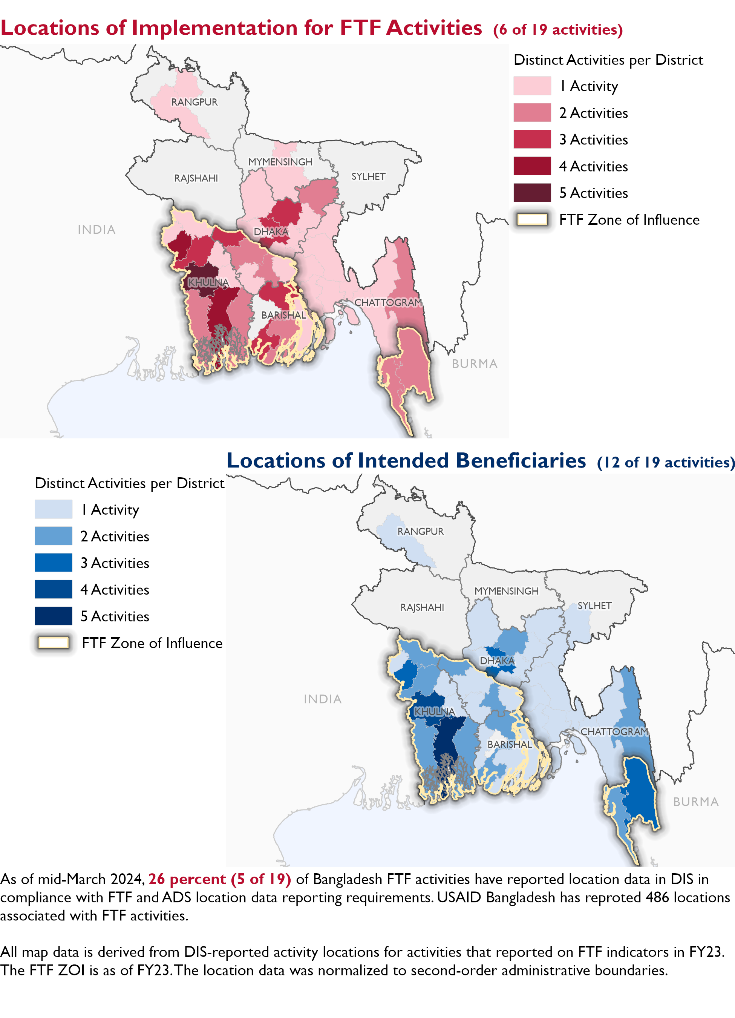

### Appendix 1: Response to “Not on track” Performance Targets

This section provides space for USAID Bangladesh to provide an explanation of why the following PTs are not on track and how you could adjust to be on track in the coming year(s). To help in your response(s), the relevant section of the FTF/GFS Key Issue Narrative (KIN) is provided, as it *may be* useful in drafting a responses. Note that the KIN is addressing the sum of the out year targets (FY 2023) set by the USAID Bangladesh activities that are reporting on each PT. The FY 2023 out year targets were set prior to the establishment of the FY 2030 Performance Targets, so the below explanations from the KIN may not apply to the Performance Target deviation.

* In Section 4 of the FTF KIN, your OU discusses FY24 and FY25 targets, while these Scorecards are addressing progress against a trajectory from historical reporting to your OU’s FY30 target. Also, the FY 2023 out year targets were set prior to the establishment of the FY 2030 Performance Targets. Therefore, the below explanations from the KIN may not apply to these FY30 Performance Target deviations.
* These responses will be used to compile a Congressional report, the GFSS Implementation Report, to discuss progress against the FTF FY 2030 Performance Targets, as mandated by the GAO.
* Only PTs that are ‘Not on Track’ require review and explanation from the OU.

Include in the response:

1. An explanation of why this target is not on track. Explanations may include that the OU/Mission was not aware of the target prior to planning activities.
2. Planned actions for ‘not on track’ targets. Planned actions may include the launch of new activities, building awareness, holding portfolio reviews, or other suggestions.
3. Limit responses to 100 words.

## Performance Target 2: Gender financing ratio [Not on Track]

*Excerpt from FY23 KIN Section 4 to consider:* FTF Aquaculture and Nutrition, CSISA Mechanization and Extension (CSISA MEA), and FTF Livestock and Nutrition projects reported FY 2023 results against this indicator. Two of the projects exceeded their targets, but the Livestock project fell short and so the overall aggregate result was 39 percent lower than the target. Due to a delay in negotiations, the Livestock project was only able to partner with two financial service providers, out of its target of three, to extend livestock loans to dairy, beef, and goat farmers and other market actors. Therefore, it could not facilitate the targeted amounts of loan access. The outyear targets declined due to the Aquaculture project ending in FY 2023. For FY 2024, the CSISA MEA and the Livestock projects set targets of $1,100,000 and $7,058,878 respectively, based on their plans to facilitate access to credit for target beneficiaries. USAID will revisit the FY 2025 targets during the FY 2024 PPR and adjust as needed based on FY 2024 results, implementation experience, and start-up time of the new activities.

#### Enter USAID Bangladesh (BANGLADESH) response below:

## Performance Target 3: Hectares under climate adaptive and risk management practices [Not on Track]

*Excerpt from FY23 KIN Section 4 to consider:* total of seven projects reported FY 2023 results for this indicator, with the overall result being 47 percent higher than the target. This is primarily because of the overachievement by the Aquaculture project, the Horticulture project, and the Livestock project. The Aquaculture project, which was scheduled to end this year in February, received a time extension through November. As a result, the project was able to reach more aquaculture beneficiaries than targeted. The Horticulture project formed additional partnerships with input firms, which contributed to covering more crop lands. In addition, the Livestock project was able to cover more lands for fodder cultivation thanks to additional outreach and training for the farmers, leading to a higher area coverage. Future outyear targets will decline due to the Aquaculture project ending in 2023. The rest of the projects as well as the new CSA project have set FY 2024 and FY 2025 targets based on their annual work plans and FY 2023 implementation experience. USAID will revisit the FY 2025 targets during the FY 2024 PPR and adjust as needed based on FY 2024 results, implementation experience, and start-up time of the new activities.

#### Enter USAID Bangladesh (BANGLADESH) response below: